Debarment Check

Prior to being invited to participate in development/authoring of a publication sponsored by Genzyme/Sanofi, a debarment check must be completed for each US author.

|  |  |
| --- | --- |
| Author Information |  |
| Author Name | Mariko Kita |
| Name of Institution/Organization | Virginia Mason Hosp & Seattle Med Ctr |
| City, State | Seattle, Washington |

|  |  |
| --- | --- |
| Source for Search | Result |
| Office of Inspectors General List of Excluded Individuals. | No, individual is not listed |

If the potential author is listed on any of the above, they may not be invited to author a publication sponsored by Genzyme or Sanofi; advise publication lead of findings of this search.

Once the debarment check has been completed, upload this document to the appropriate record in Datavision.

**Debarment check completed by: Krista Yheaulon  
Date check completed: 07-April-2020 17:25:30**

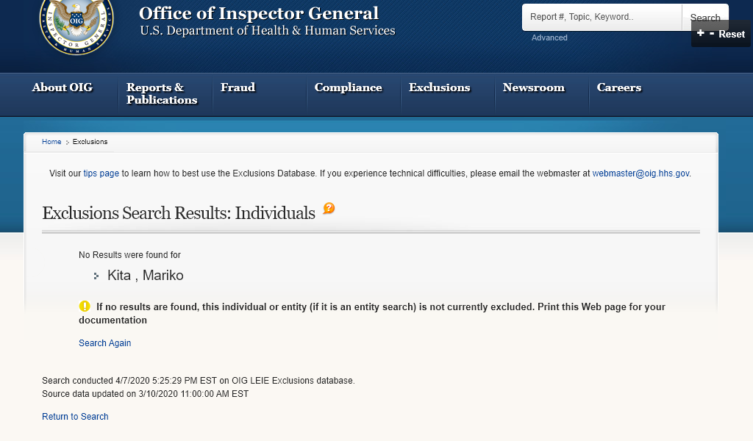

Search conducted 4/7/2020 5:25:29 PM EST on OIG LEIE Exclusions database. Source data updated on 3/10/2020 11:00:00 AM EST